

TECHNICAL FEATURES CEL-5040 AND CFI-5041 ELECTRIC
One-section table.
UPHOLSTERY: wood fiber board covered with 50 mm foam, density 30 kg, upholstered with fire-retardant, antibacterial synthetic leather.
STRUCTURE: epoxy-coated steel tube.
Base with 4 retractable wheels of 75 mm diameter, with locking system and 1 leveling leg. (NOT suitable for transporting people).
Set of two securing straps.
Paper roll holder.
APPROXIMATE DIMENSIONS:
Inclined plane at 90º
Length 2000 mm, width 660 mm.
CEL-5040 height adjustable (540 to 940 mm) via electric motor with foot control.
CFI-5041 fixed height of 540 mm.
Maximum supported weight: 135 kg.
Weight of the table: 90 kg.
OPTIONAL: MES-5042
Structure warranty 5 years, motor 2 years.
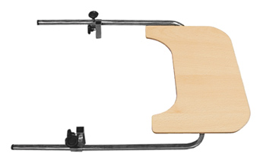

MES-5042

